WINTER FERN & TREE HIKE

MOUNT TOBY FOREST
SUNDERLAND MA

FRIDAY NOV 27, 2026 1-3pm

Led by Randy Stone,
Pioneer Valley Fern Society

We’ll hike parts of the Robert Frost and other trails to the famous Sunderland Caves, identifying trees, shrubs and ferns along the way. Winter ferns include wood ferns, Christmas fern, polypody, grape ferns, ebony & maidenhair spleenworts.
2-mile hike, moderate terrain, a few steep sections.

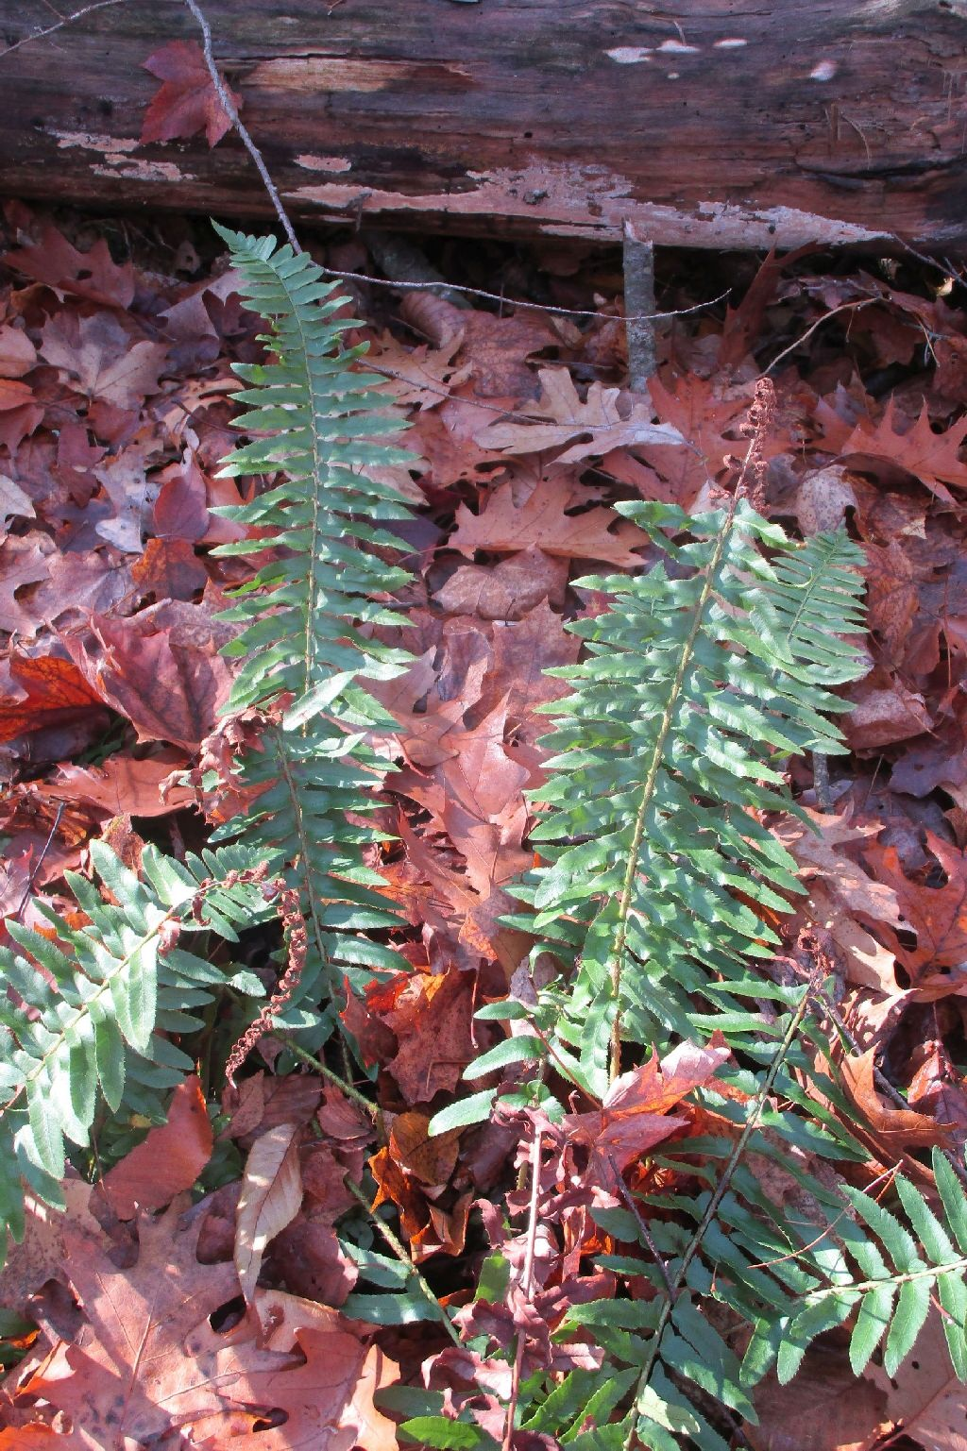
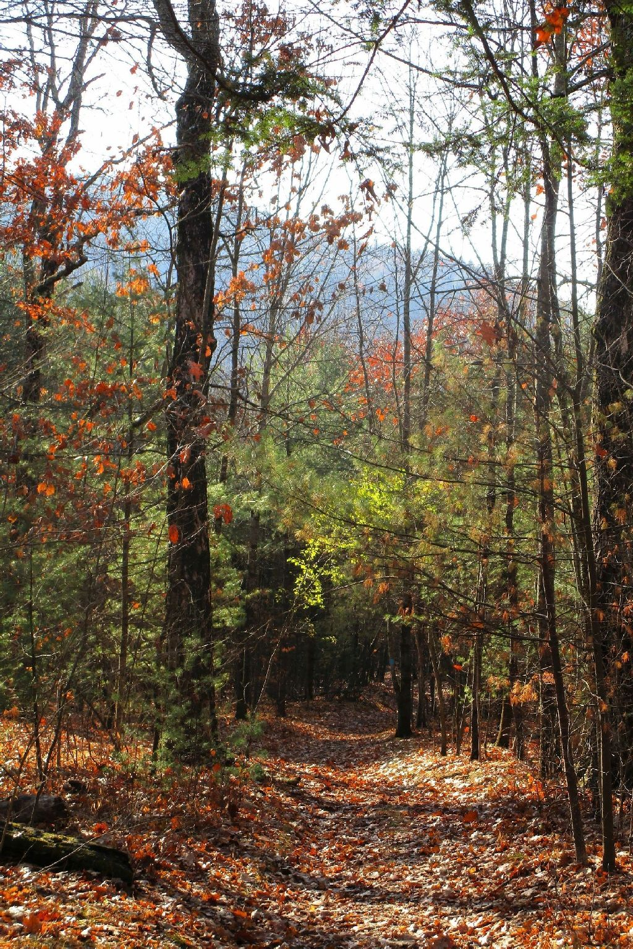
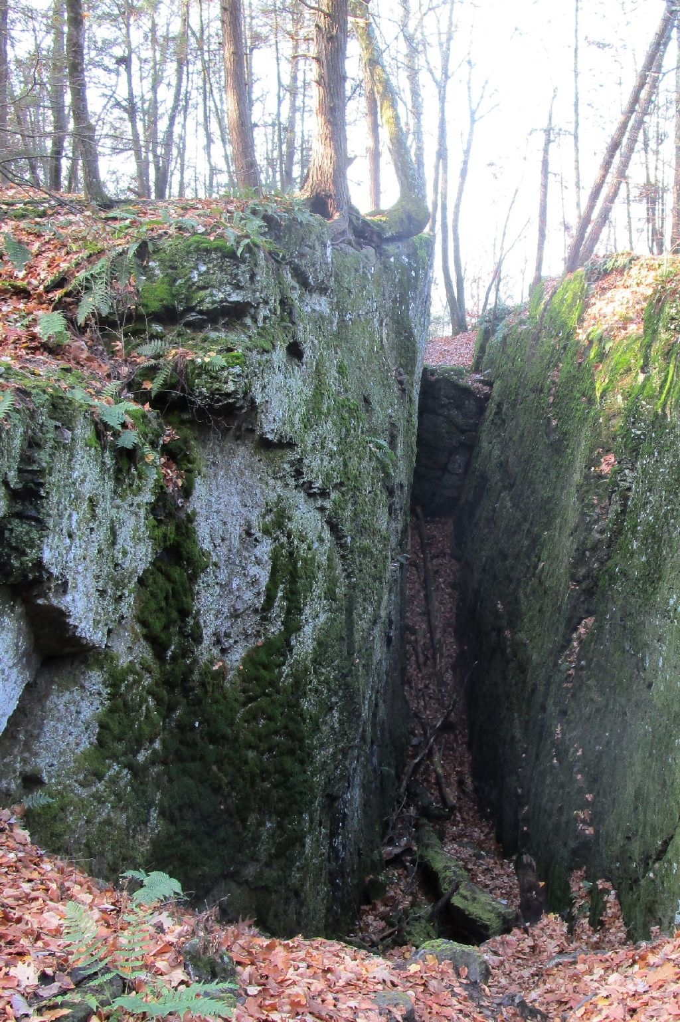
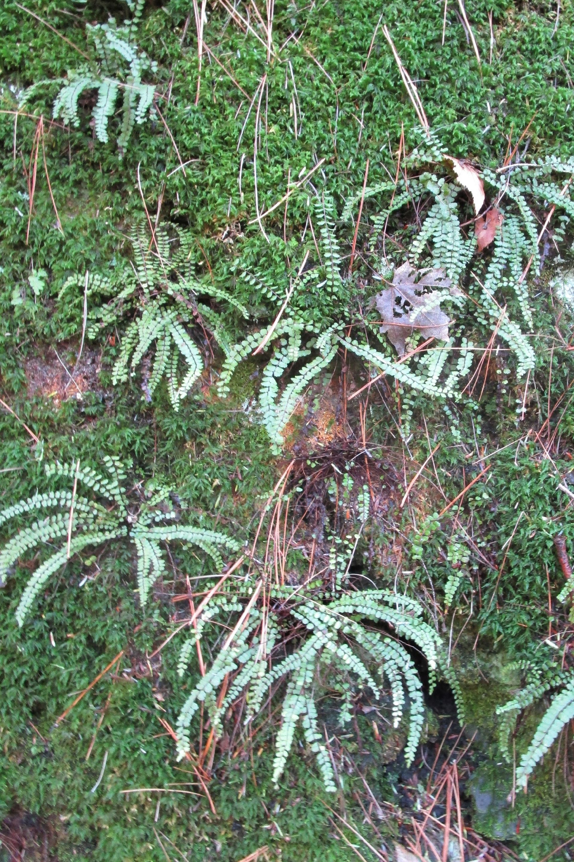

Directions: Meet at the trail head parking area on Reservation Rd. in Sunderland. From Sunderland center follow Rt. 47 north to the Montague town line. Just after the town line sign, turn right onto Reservation Rd. The gate, trail head parking area and kiosk are 1/2 mile on the right.

Pre-registration not required. Free. Cancelled if bad weather. Check PVFS website http://pvfernsociety.org or pioneervalleyfernsociety@gmail.com

